## THE HELLENIC ASSOCIATION FOR AMERICAN STUDIES

**in collaboration with**

**THE FULBRIGHT FOUNDATION IN GREECE**

**would like to invite you to**

**A two-part online event hosted via Zoom   
for REGISTERED PARTICIPANTS ONLY**

**Thursday, March 13, 2025, 6:00 pm–7:30 pm EEST**

**Friday, March 14, 2025, 6:00 pm–7:30 pm EEST**

To register for either lecture or for both, please click on the following link and fill in your information. The Zoom event link will then be emailed to you prior to the webinar date:

[**https://docs.google.com/forms/d/e/1FAIpQLSfFYaH7Xvg-kevgv2aAJlm6HHzgeFvf5_jNhOvpZbCOweLLWg/viewform**](https://docs.google.com/forms/d/e/1FAIpQLSfFYaH7Xvg-kevgv2aAJlm6HHzgeFvf5_jNhOvpZbCOweLLWg/viewform)

HELAAS and the Fulbright Foundation in Greece Intercountry Exchange Program are pleased to invite you all to a series of lectures on 19th-century speculative (science) fiction by

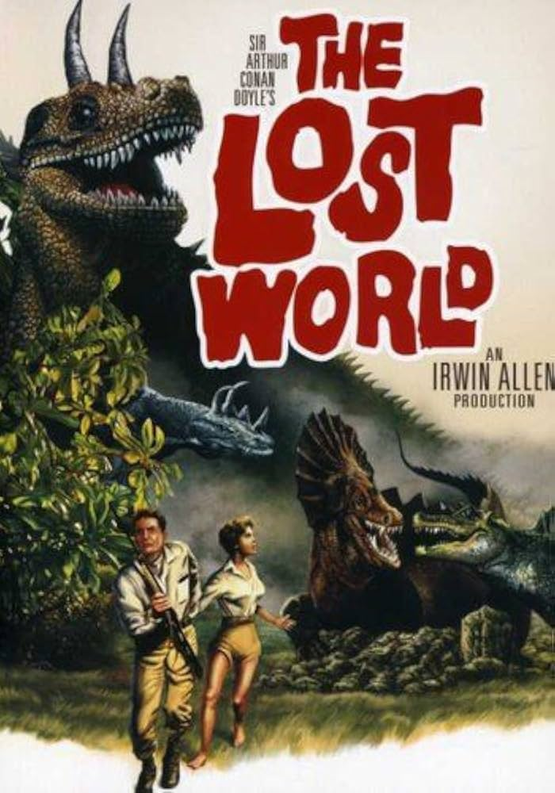**Dr. Katie Googe**

**Thursday, March 13, 2025--Lecture**

**“In Search of Lost Worlds: Time, Imperialism,   
and Nineteenth Century Science Fiction”**

At the end of the nineteenth century, thinkers such as Hegel began to theorize that the United States and Western Europe were the peak of a historical evolution from “barbarism” to “civilization.” This became an essential element in propaganda about “civilizing” people around the world through colonization. At the same time, it contributed to writers’ fascination with imaginative stories about contact between different times and “stages” of civilization in the form of science fiction. This talk will examine how the popularization of this theory of time connects the United States’ overseas imperial ventures and the emergence of science fiction.

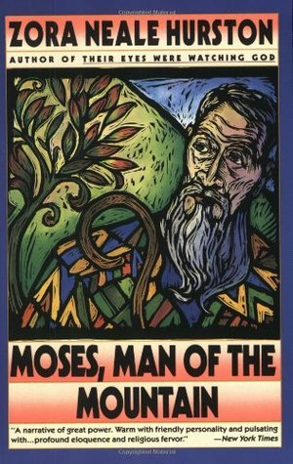

**Friday, March 14, 2025--Online Masterclass   
for students and scholars of literature**

**“Diaspora and Hybrid Histories in Zora Neale Hurston’s *Moses, Man of the Mountain*”**

This talk will discuss Zora Neale Hurston’s emphasis on hybrid knowledge production in her 1939 novel *Moses, Man of the Mountain*. In this novel, Hurston rewrites the Exodus narrative to incorporate her anthropological training, Black folklore, and African diasporic religious practices.  Hurston uses these diverse influences to create an alternate history that undermines the rigid racial hierarchies of the 1930s and to argue that cultural purity is a harmful myth.

**Biographical note:**



Dr. Katie Googe is Fulbright Postdoctoral Teaching and Research Fellow in the Department of English and American Studies, Masaryk University, Czech Republic. She has taught various courses at universities in the U.S. and Spain. Her interests include American speculative fiction, religious studies and comparative literature.